COMPUTER PROGRAMMING LAB 10

EXAMPLE NO 1:

using System;

namespace
{
class Program
{
static void AreaOfRectangle(int L, int B)
{
int area = L * B;
Console.WriteLine("Area of Rectangle={0}", area);
}
static float AreaOfCircle(int r)
{
float pi = 3.142f;
float area1 = pi * r * r; return area1;
}
static void DisplayTitle()
{
Console.WriteLine("FUNCTIONS LAB");
}
static void Main(string[] args)
{
DisplayTitle(); int L, B, R;
float areaofcircle;
Console.WriteLine("Enter the Lenght of Rectangle"); L = Convert.ToInt32(Console.ReadLine()); Console.WriteLine("Enter the Breath of Rectangle"); B = Convert.ToInt32(Console.ReadLine()); Console.WriteLine("Enter the Radius of Circle");
R = Convert.ToInt32(Console.ReadLine()); AreaOfRectangle(L, B);
areaofcircle = AreaOfCircle(R); Console.WriteLine("Area of Circle={0}", areaofcircle);

}
}
}

OUTPUT:

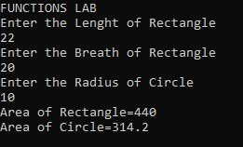

TASK 01:

using System;

namespace
{
class Program
{
static void cubeAndSquare(int num1)
{
int sum = num1 * num1;
int cube = num1 * num1 * num1;
Console.WriteLine("Square is {0} and Cube is {1}", sum, cube);

}
static void Main(string[] args)
{
int num1;
Console.WriteLine("Enter Number"); num1 = int.Parse(Console.ReadLine()); cubeAndSquare(num1);
}
}
}

OUTPUT:
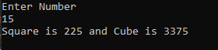
TASK 02:

using System;

namespace
{
class Program
{
static void CalculateTable(int num, int start, int end)
{

for (int i = start; i <= end; i++)
{
Console.WriteLine("{0} x {1} = {2}", num, i, num * i);
}
}
static void Main(string[] args)
{
Console.WriteLine("Enter any Number whose Table you want to print"); int num1 = int.Parse(Console.ReadLine());
Console.WriteLine("Enter The Starting point of Table"); int Start = int.Parse(Console.ReadLine()); Console.WriteLine("Enter the Ending point of Table"); int End = int.Parse(Console.ReadLine()); CalculateTable(num1, Start, End);

}
}
}

OUTPUT:
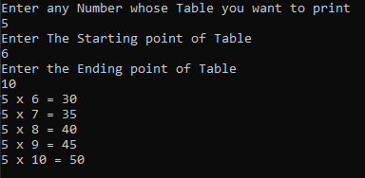
TASK 03:

using System;

namespace
{
class Program
{
static void MinMaxFunction(int[] array, int length)
{
int min = 0, max = 0;
for (int i = 0; i < length; i++)
{
Console.WriteLine("Enter Num {0}", i + 1); array[i] = int.Parse(Console.ReadLine());
if (i == 0)
{
min = array[i]; max = array[i];
}

if (min > array[i])
{
min = array[i];
}
if (max < array[i])
{
max = array[i];
}
}
Console.WriteLine("min = " + min); Console.WriteLine("max = " + max);
}
static void Main(string[] args)
{
Console.WriteLine("Enter Length of Array"); int Length = int.Parse(Console.ReadLine()); int[] Array = new int[Length]; MinMaxFunction(Array, Length);

}
}
}

OUTPUT:
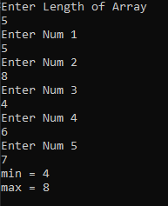
TASK 04:

namespace
{
class Program
{
static void ArrayRevFunction(int[] array, int length)
{
for (int i = 0; i < length; i++)
{
Console.WriteLine("Enter Num {0}", i + 1); array[i] = int.Parse(Console.ReadLine());

}
Console.WriteLine("Reverse Array: "); for (int i = length - 1; i >= 0; i--)
{
Console.WriteLine("{0}", array[i]);
}
}
static void Main(string[] args)
{
Console.WriteLine("Enter Length of Array"); int Length = int.Parse(Console.ReadLine()); int[] Array = new int[Length]; ArrayRevFunction(Array, Length);
}
}
}

OUTPUT:
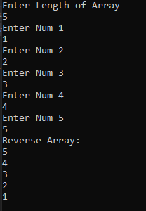
TASK 05:

using System;
using System.Collections.Generic; using System.ComponentModel; using System.Data;
using System.Drawing; using System.Linq; using System.Text;
using System.Threading.Tasks; using System.Windows.Forms;

namespace WindowsFormsApp1
{

public partial class Form1 : Form
{
public Form1()
{
InitializeComponent();
}
static void add(int num1, int num2)
{
int sum=num1 + num2; MessageBox.Show("The sum is" + sum);
}
static void sub(int num1, int num2)
{
int sub=num1 - num2; MessageBox.Show("The sub is" + sub);
}
static void mul(int num1, int num2)
{
int mul=num1 * num2; MessageBox.Show("The multiply is" + mul);
}
static void div(int num1, int num2)
{
float div=Convert.ToSingle(num1)/Convert.ToSingle(num2); MessageBox.Show("The Divide is" + div);
}
private void label1_Click(object sender, EventArgs e)
{}
private void label2_Click(object sender, EventArgs e)
{}
private void radioButton1_CheckedChanged(object sender, EventArgs e)
{}
private void label3_Click(object sender, EventArgs e)
{}
private void button1_Click(object sender, EventArgs e)
{
int num1 = Convert.ToInt32(txtNum1.Text); int num2 = Convert.ToInt32(txtNum2.Text); if(rbAdd.Checked==true)
{
add(num1, num2);
}
else if(rbSub.Checked==true)
{
sub(num1, num2);
}
else if(rbDiv.Checked==true)
{
div(num1, num2);
}
else if (rbMul.Checked == true)
{mul(num1, num2);} else{

MessageBox.Show("Invalid input");
}
}
}
}

OUTPUT:

